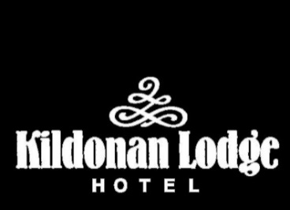
Starters
Freshly prepared seasonal Soup of the Day served with homemade bread roll (V)

Traditional Scottish Haggis, neeps and tatties with Whisky cream sauce (can be served as a main)
Scottish Smoked Salmon with capers, lemon oil and homemade bread roll
Grilled Goat’s Cheese glazed with honey and rosemary on a bed of beetroot salad
Salmon and crab Fish Cake served with Garlic and Herb Mayo
Avocado and Prawn salad with spicy marie rose sauce
Traditional Cullen Skink
Mains
Homemade beef Burger with baby gem lettuce, tomato, onion rings and hand cut
chunky chips
Prawn and Pancetta Linguine with spinach and white wine sauce
Traditional Spaghetti Bolognese topped with parmesan shavings
Homemade Beer battered Haddock with hand cut chunky chips, mushy peas and
homemade tartar sauce
Grilled Peppers stuffed with mushroom and onion risotto with a balsamic glaze
Pan seared Seabass with baby potatoes, asparagus and cherry tomatoes
8oz Sirloin Steak with hand cut chunky chips or baby potatoes, confit of mushroom and Charlotte onions
Brandy and peppercorn sauce or Brandy and cream sauce

Desserts
Homemade Sticky Toffee Pudding, butterscotch sauce and Arran salted caramel ice cream
Selection of Arran Traditional Ice Creams
*Selection of Mature Scottish Cheeses served with red onion chutney, grapes and homemade oatcakes
Chocolate and Almond Tarte served with vanilla ice cream

