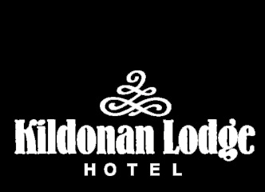

Kildonan Lodge Hotel
Breakfast Menu

Good Morning! Please help yourself to the buffet and we will take your order for a hot cooked breakfast

On the Buffet

Juice - Orange, Apple or Grapefruit Juice
Grapefruit segments – Homemade fresh fruit salad – Natural yogurt – Fruit yogurt – Fresh fruit – Cereal – Muesli – Prunes (Please ask for)
Cheese – Cold meats – Oatcakes (please ask for)
Croissants

Made to order

Brown or White toast
Tea, Coffee, Earl Grey, Hot Chocolate and a selection of fruit teas

Scottish oats served plain or with a choice of toppings:
Cream and Brown Sugar
Honey and Sultanas

Traditional Scottish Breakfast
Grilled Bacon, Sausage, Tomato, Mushrooms, Grilled Potato Scone and a choice of Fried, Poached or Scrambled eggs
Or select your choice from above
A side of Haggis, Black Pudding or beans are also available.

*******
Boiled Eggs

******
Scotch Pancakes served with crispy bacon and maple syrup

******
Smoked Salmon and scrambled eggs

******
Scottish Kippers

******
Freshly Prepared Omelette
With the following fillings to choose from:
Mushrooms, Tomato, Ham, Cheese

