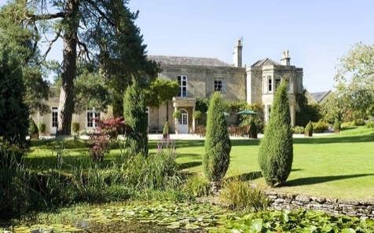
Guyers House
À La Carte Menu
Starters
Smoked Duck Breast, Pear, Candied Hazelnuts, Orange Dressing
8.5
8.5
8.5
7.5
7.5
6.5
.00

Ham Hock Terrine with Apple Chutney, Toasted Croutes
Smoked Salmon, Pickled Fennel & Cucumber, Lemon Dressing
Goats Cheese Mousse, Beetroot Salad, Seeded Cracker
Leek, Potato & Cheddar Croquette, Apple & Walnut Salad
Soup Of the Day with Crusty Bread

Main Courses
18
20
16
28
15
16

Confit Duck Leg, Puy Lentils, Savoy Cabbage, Red Wine Sauce
Pan Fried Fillet of Cod, Crushed Potatoes, Samphire, Sauce Vierge
Wild Mushroom Risotto, Parmesan, Rocket
8oz Ribeye Steak, Field Mushrooms, Grilled Tomato, Truffle Fries (£8.50 Supplement with packages)
Beef Burger, Cheddar Cheese, Sweet Pepper Relish, Gherkin, Tomato, Gem, Fries
Beer Battered Fish & Chips, Crushed Peas, Tartare Sauce

Desserts
7
7
7
7
6
9.5

Chocolate & Hazelnut Delice, Chocolate Gel, Chantilly Cream
Strawberry Cheesecake, Strawberry Sorbet
Sticky Toffee Pudding, Toffee Sauce, Clotted Cream Ice Cream
Selection of Ice Creams & Sorbets
Guyers House Cheese Board (£3.50 Supplement with packages)

Please Advise a Member of The Team of Any Allergens or Dietary Requirements Prior to Ordering.
A 10% Discretionary Service Charge Will Be Added to Your Bill.

